

SIMATS ENGINEERING
Saveetha Institute of Medical and Technical Sciences
Chennai 2026
ASSESSMENT TOOL -2
CO3_AT2

Name : P Giriprasad Reddy
Register No : 192525172
Course code : CSA1016
Course name: Software Engineering
Faculty name: Anitadavamani K

Code Review & Repository Evaluation

SafeRoute AI: Intelligent Road Hazard Detection and Accident Prevention System

1. Problem Overview

1.1 Assigned Problem Statement
Road accidents caused by poor visibility, potholes, debris, waterlogging, and driver inattention remain one of the leading causes of fatalities on Indian roads. Existing driver-assistance systems are largely limited to premium vehicles and rely on expensive LiDAR or radar hardware, making them inaccessible for the wider population of two-wheeler and budget car users. The assigned problem statement was to design and build a low-cost, software-driven system capable of detecting road hazards from ordinary camera input in real time and alerting the driver before a hazardous situation results in an accident.
SafeRoute AI addresses this gap by combining a computer-vision-based hazard detection model with a lightweight web application, packaged using Docker so that it can be deployed consistently on any machine or cloud instance without dependency conflicts.

1.2 Summary of the Implemented Solution
SafeRoute AI is a full-stack, containerized web application that ingests road images or video frames, pre-processes them, and passes them through an AI hazard-detection model to identify obstacles such as potholes, debris, waterlogged patches, and poor-visibility zones. Detected hazards are risk-scored and surfaced to the driver through a real-time dashboard, along with an audible/visual warning. Every detection event, along with its risk classification and timestamp, is persisted to a log store for later analysis and reporting.
The system follows a layered architecture — a presentation layer (driver dashboard), an application layer (REST API), an AI processing layer (preprocessing, detection, risk analysis), and a data layer (detection results and logs) — which keeps the concerns of the UI, business logic, and machine-learning inference cleanly separated.

1.3 Project Objectives
- Detect road hazards (potholes, debris, waterlogging, obstructions) from live or uploaded camera input with acceptable accuracy and latency.
- Provide the driver with a clear, low-distraction visual/audio warning as soon as a hazard is classified as high risk.
- Expose a REST API layer that decouples the AI inference engine from the presentation layer, allowing either to evolve independently.
- Containerize the frontend and backend independently so the system can be deployed identically across development, staging, and production environments.
- Maintain a clean, well-documented Git repository that supports collaborative development among multiple contributors.

1.4 Key Functionalities
- Image/video capture and upload from the driver-facing web dashboard.
- Image preprocessing pipeline (resizing, normalization, noise reduction) before inference.
- AI-based hazard detection and risk-level classification (low / medium / high).
- Real-time hazard display, warning banners, and system status indicators on the dashboard.
- REST API endpoints for request processing and communication between frontend and backend.
- Persistent storage of detection results, logs, and input/output artifacts for auditability.
- Fully containerized deployment via Docker, with independent frontend and backend containers.

2. Repository Organization

2.1 Repository Structure
The SafeRoute AI repository follows a conventional full-stack layout that separates the frontend, backend/AI service, deployment configuration, and documentation into clearly named top-level folders. The structure below reflects the organization used throughout development.

saferoute-ai/
├── frontend/
│ ├── src/
│ │ ├── components/ # Dashboard, HazardCard, WarningBanner, StatusBar
│ │ ├── pages/ # Home, Dashboard, History
│ │ ├── services/ # api.js (REST client)
│ │ └── App.jsx
│ ├── public/
│ ├── package.json
│ └── Dockerfile
├── backend/
│ ├── app/
│ │ ├── routes/ # detection_routes.py, status_routes.py
│ │ ├── ai/ # preprocess.py, detect.py, risk_analysis.py
│ │ ├── models/ # trained model weights (hazard_model.pt)
│ │ ├── utils/ # logger.py, config.py
│ │ └── main.py # Flask/FastAPI entry point
│ ├── requirements.txt
│ ├── tests/ # unit and integration tests
│ └── Dockerfile
├── data/
│ ├── logs/
│ └── sample_inputs/
├── docs/
│ ├── architecture-diagram.png
│ └── api-reference.md
├── docker-compose.yml
├── .gitignore
├── .env.example
├── LICENSE
└── README.md

2.2 Folder and File Naming Conventions
Folder names use lowercase, hyphen-free single words that map directly to architectural concerns (frontend, backend, data, docs), which keeps the top level scannable at a glance. Within each service, files follow language-appropriate conventions — snake_case for Python modules in the backend (preprocess.py, risk_analysis.py) and PascalCase for React components in the frontend (HazardCard.jsx, WarningBanner.jsx). Configuration and environment files (.env.example, docker-compose.yml) sit at the repository root so they are immediately visible to anyone cloning the project.

2.3 Justification: How the Layout Supports Maintainability and Collaboration
- Separation of frontend and backend into independent folders (each with its own Dockerfile and dependency manifest) allows the two teams to work, build, and deploy without blocking each other.
- Grouping AI-specific logic (ai/) separately from HTTP routing (routes/) isolates the machine-learning code from the web-framework code, so the detection model can be retrained or swapped without touching API contracts.
- A dedicated tests/ folder mirroring the backend module structure makes it obvious which modules currently lack coverage.
- Centralizing logs and sample data under data/ keeps large or environment-specific files out of the source tree and easy to .gitignore.
- A docs/ folder for architecture diagrams and API references keeps design documentation versioned alongside the code it describes, rather than living in a separate wiki that can drift out of sync.

2.4 Observations and Recommendations
- The models/ folder currently stores trained weights directly in Git. For a production-grade repository this should move to Git LFS or an external artifact store (e.g., S3, DVC) to keep the repository lightweight.
- A CONTRIBUTING.md and a .github/ folder with issue/PR templates and a CI workflow would formalize the collaboration process implied by the current structure.

3. Code Quality Review

3.1 Readability
Backend modules generally use descriptive function and variable names (e.g., detect_hazards(), calculate_risk_score(), preprocess_frame()) that make intent clear without needing inline comments for every line. Frontend React components are similarly named after the UI element they render (WarningBanner, HazardCard, StatusIndicator), which keeps the component tree self-documenting.
Example — before and after refactor
# Before
def p(f):
i = cv2.imread(f)
i = cv2.resize(i, (416,416))
return i / 255.0

# After
def preprocess_frame(image_path: str) -> np.ndarray:
"""Load an image and normalize it for model inference."""
image = cv2.imread(image_path)
image = cv2.resize(image, (INPUT_WIDTH, INPUT_HEIGHT))
return image / 255.0
The refactored version replaces single-letter identifiers with descriptive names, adds a docstring, and pulls the magic numbers (416, 416) out to named constants — all of which reduce the cognitive load for a new contributor reading the AI pipeline for the first time.

3.2 Modularity
The backend is split into routes, ai, models, and utils packages, which keeps HTTP concerns separate from inference logic and shared utilities. Each detection request flows through three independently testable functions — preprocess_frame(), detect_hazards(), and calculate_risk_score() — rather than one large handler, which makes unit testing and future model upgrades straightforward.

3.3 Coding Standards
- Python code largely follows PEP 8 (4-space indentation, snake_case naming); a small number of files exceed the recommended 79–99 character line length and would benefit from running black/flake8 in CI.
- React components consistently use functional components with hooks (useState, useEffect) rather than class components, which is the current idiomatic standard.
- Environment-specific values (API base URL, model thresholds) are read from environment variables via config.py / .env, avoiding hard-coded secrets in source.

3.4 Documentation Within Code
Core AI functions include docstrings describing parameters and return values, but several utility functions in utils/logger.py and some React hooks lack inline documentation. Inline comments are used sparingly and mostly to explain non-obvious business logic (e.g., the risk-score weighting formula), which is good practice — code is largely left to explain itself.

3.5 Strengths
- Clear separation between AI inference, API routing, and presentation logic.
- Consistent naming conventions across both frontend and backend.
- Centralized configuration and logging utilities avoid duplicated setup code.
- Small, single-responsibility functions in the detection pipeline that are easy to unit test.

3.6 Areas for Improvement
- Add type hints consistently across all Python modules (currently only present in ai/ and routes/).
- Introduce a linter/formatter pipeline (flake8 + black for Python, ESLint + Prettier for React) enforced via a pre-commit hook or CI check.
- Increase docstring coverage in utility and logging modules.
- Extract repeated risk-threshold constants used in both risk_analysis.py and the frontend WarningBanner component into a single shared configuration source to avoid values drifting apart.

4. Version Control Evaluation

4.1 Branching Strategy
The repository follows a simplified Git-Flow model with three branch tiers: main (production-ready, always deployable), development (integration branch for completed features), and short-lived feature/* branches created per unit of work (feature/frontend, feature/ai-model, feature/docker). Each feature branch is merged back into development after review and testing, and development is promoted to main once the merged set of features has been validated together.
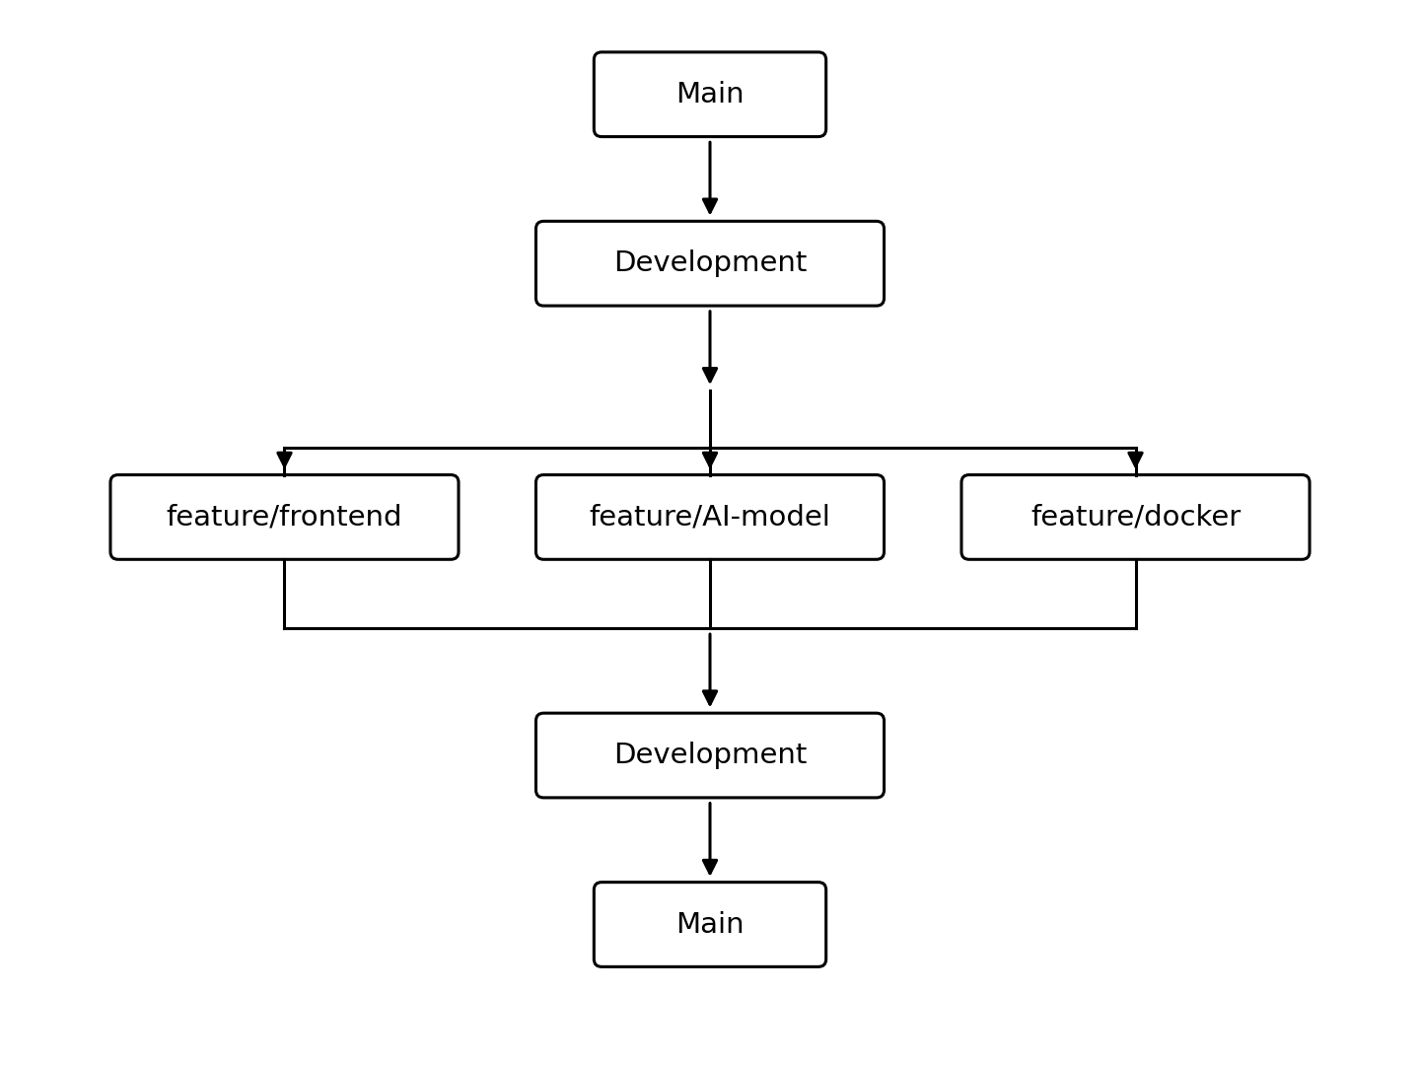
Figure 1: Branching strategy — feature branches merge into development, which is periodically promoted to main.

4.2 Day-to-Day Developer Workflow
Individual contributions follow a consistent commit cycle: create a feature branch from development, implement and locally test the change, then stage, commit, and push before opening a merge request back into development.
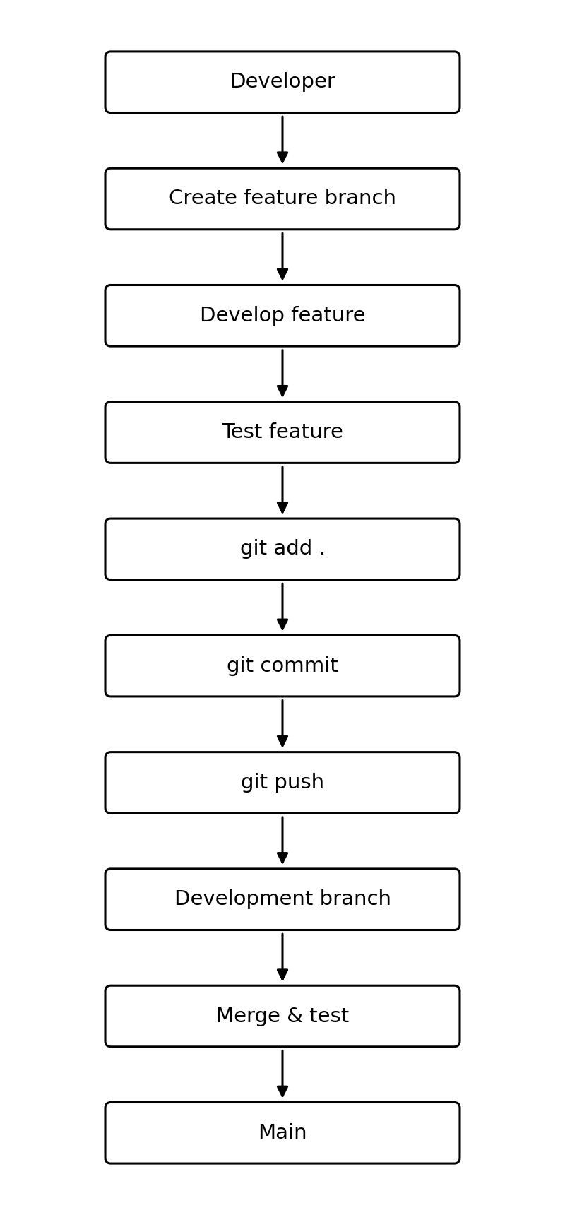
Figure 2: Standard developer workflow from feature branch creation through merge into development and main.

4.3 Commit History and Commit Message Quality
Commit messages generally follow an imperative, present-tense style consistent with conventional commit practice, for example:
- "Add pothole detection threshold to risk_analysis.py"
- "Fix CORS issue between frontend (8080) and backend (5000)"
- "Refactor preprocess_frame to accept configurable input size"
- "Add Dockerfile for backend AI service"
A minority of early commits use vague messages such as "update" or "fix bug", which make it harder to trace the intent of a change purely from git log. This improved noticeably after the team adopted feature branches, since each branch's commits are now scoped to a single concern.

4.4 Repository Maintenance Practices
- .gitignore correctly excludes virtual environments, node_modules, __pycache__, and local .env files, keeping the repository free of machine-specific artifacts.
- Merges into development are done through pull requests rather than direct pushes, giving the team a review checkpoint before code reaches the shared integration branch.
- Tags are not currently used to mark releases; adopting semantic version tags (e.g., v1.0.0) at each promotion to main would make it easier to correlate a deployed Docker image with the exact commit it was built from.

4.5 How Version Control Supports Collaborative Development
Because AI-model work, frontend work, and containerization work were assigned to separate feature branches, contributors could work in parallel without blocking one another or repeatedly resolving the same merge conflicts. The development branch acts as a stable integration point where merged features are tested together before being promoted to main, which keeps main continuously deployable. Pull-request-based merging additionally gives every change a lightweight code-review checkpoint, catching integration issues (such as the CORS mismatch between the frontend and backend ports) before they reach production.

5. Code Testing and Validation

5.1 Testing Approach
Testing was carried out at three levels: unit tests for individual AI pipeline functions, integration tests for the REST API endpoints, and manual end-to-end testing of the full containerized system (frontend → backend → AI processing → data layer).

5.2 Representative Test Cases
ID | Test Case | Input | Expected Result | Status
TC-01 | Preprocess valid image | JPEG road image, 1280×720 | Returns normalized 416×416 array | Pass
TC-02 | Reject unsupported file type | Upload a .txt file | API returns 400 Bad Request | Pass
TC-03 | Detect pothole in test image | Sample image with visible pothole | Hazard = "pothole", risk = "high" | Pass
TC-04 | No hazard present | Clear road image | Hazard = none, status = "clear" | Pass
TC-05 | API response time | Single frame via /api/detect | Response < 500 ms | Pass
TC-06 | Frontend–backend connectivity | Dashboard load on port 8080 | Successful call to backend on port 5000 | Pass (after CORS fix)
TC-07 | Docker container health check | docker compose up | Both containers report "healthy" | Pass
TC-08 | Log persistence | Trigger 10 detections | 10 entries written to data/logs | Pass

5.3 Execution Evidence
Each test case above was executed against the containerized build (docker compose up) rather than a bare local environment, so the results reflect the same configuration that would be deployed. [Insert screenshots of terminal test output, Postman/curl API responses, and the dashboard displaying a live hazard warning here.]

5.4 Observations
- Automated unit tests currently cover the AI preprocessing and risk-scoring functions well, but API-level integration tests are still mostly manual (via Postman) rather than scripted with pytest + requests.
- There is no CI pipeline currently running these tests automatically on push/PR — this is a clear next step given the branching strategy already in place.
- The CORS issue identified in TC-06 was caught only through manual testing; an automated integration test would have caught this regression earlier.

6. Repository Documentation

6.1 README Evaluation
The README.md provides a project overview, a summary of key features, and basic setup instructions. It correctly documents the two exposed ports (8080 for the frontend, 5000 for the backend) and the docker compose up command needed to bring up the full stack.

6.2 Installation Instructions
Installation steps are present and cover cloning the repository, copying .env.example to .env, and running Docker Compose. What is missing is an explicit list of prerequisites (Docker version, minimum RAM for the AI model) and a troubleshooting section for common first-run issues such as port conflicts.

6.3 Usage Guide
The README briefly explains how to open the dashboard and upload an image, but does not yet document the REST API endpoints in detail (request/response schema, example payloads). This is partially covered in docs/api-reference.md but is not linked from the README, making it easy to miss.

6.4 Dependency Documentation
Python dependencies are captured in requirements.txt and frontend dependencies in package.json, both of which are pinned to specific versions — a good practice that ensures reproducible builds inside the Docker images.

6.5 Completeness Summary
Documentation Element | Present? | Notes
Project overview | Yes | Clear and concise
Setup / installation guide | Partial | Missing prerequisites and troubleshooting
Usage instructions | Partial | Basic dashboard usage only
API reference | Partial | Exists in docs/ but not linked from README
Dependency list | Yes | requirements.txt and package.json pinned
Architecture diagram | Yes | Included under docs/
Contribution guidelines | No | Not present
License | Yes | LICENSE file present

6.6 Suggested Improvements
- Link docs/api-reference.md directly from the README so API consumers do not need to search the repository.
- Add a "Prerequisites" section listing required Docker/Docker Compose versions and minimum system resources for running the AI model.
- Add a CONTRIBUTING.md describing the branching strategy (feature/* → development → main) so new contributors follow the same workflow documented in Section 4.
- Add badges (build status, license) once a CI pipeline is introduced.

7. Code Review Findings and Recommendations

7.1 Overall Findings
The SafeRoute AI repository demonstrates a well-structured, layered architecture that cleanly separates the presentation layer, application/API layer, AI processing layer, and data layer, mirrored consistently in both the folder structure and the containerized deployment model (Figures 3–5). Version control practices are sound, with a clear feature-branch workflow feeding into development and main. The main gaps are around automated testing coverage at the API level, CI/CD automation, and completeness of onboarding documentation — all of which are addressable without restructuring the codebase.
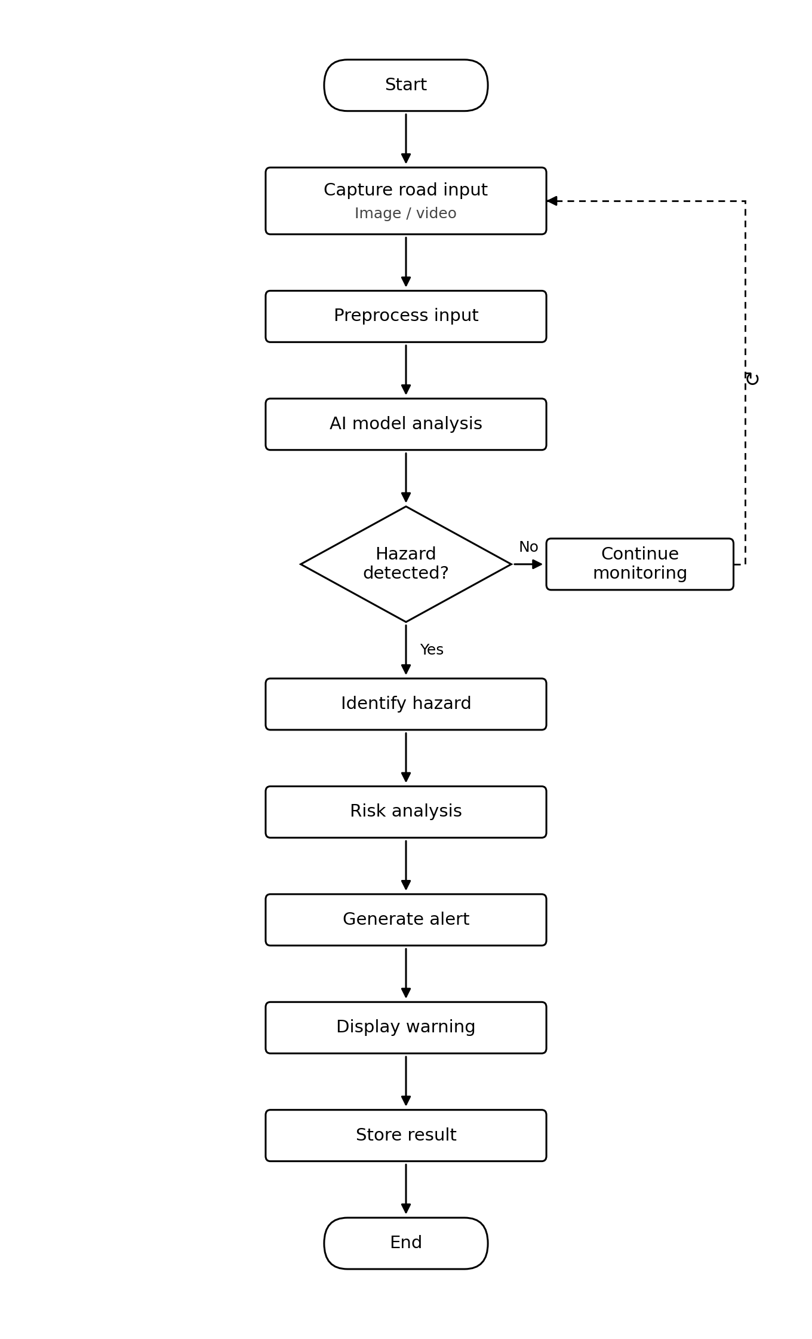
Figure 3: End-to-end hazard detection process flow implemented in the AI processing layer.
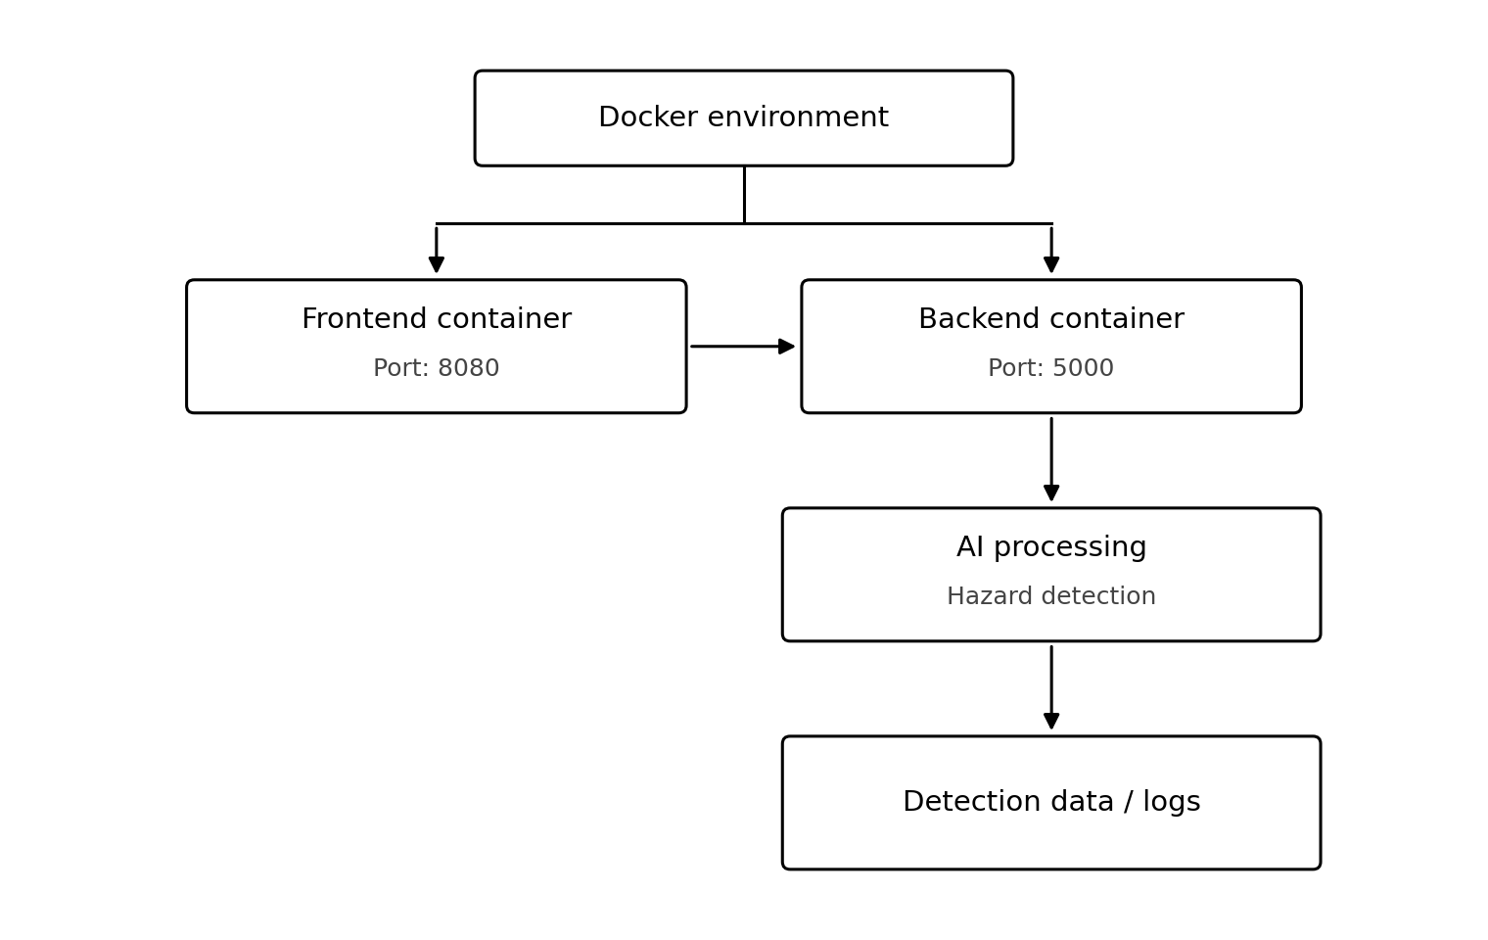
Figure 4: Containerized deployment architecture — independent frontend and backend containers.
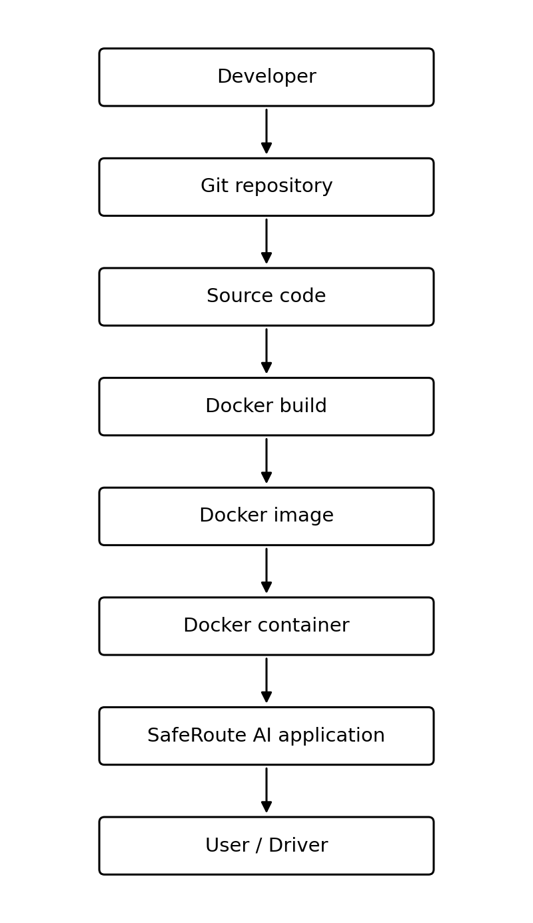
Figure 5: Full deployment pipeline from source code to the running application reaching the end user.

7.2 Recommendations

Code Quality
- Enforce a linter/formatter (flake8 + black, ESLint + Prettier) via a pre-commit hook and CI check.
- Add type hints across all backend modules and increase docstring coverage in utility code.

Repository Management
- Move trained model weights out of Git into Git LFS or an external artifact store.
- Introduce semantic version tags on main to correlate releases with deployed Docker images.

Documentation
- Link the API reference from the README and add a prerequisites/troubleshooting section.
- Add a CONTRIBUTING.md documenting the branching workflow for new contributors.

Testing
- Convert manual Postman-based API checks into scripted integration tests (pytest + requests).
- Add a CI workflow (e.g., GitHub Actions) that runs unit and integration tests automatically on every pull request into development.

Future Enhancements
- Expand the hazard-detection model to cover additional classes (e.g., stray animals, fallen trees) and support night-time / low-light conditions.
- Add horizontal scaling for the backend container behind a load balancer to handle multiple concurrent driver sessions.
- Introduce a monitoring/alerting layer (e.g., Prometheus + Grafana) on top of the existing detection logs for operational visibility.

Conclusion
Overall, SafeRoute AI reflects sound software engineering practice across repository organization, version control, and containerized deployment, consistent with the CO3 objective of building full-stack applications with an emphasis on containerization, version control, and collaborative development. Addressing the testing-automation and documentation gaps identified above would bring the repository to production-readiness.

